

Tehničke Karakteristike

|  |  |
| --- | --- |
| Specification | EM131, 4 AI×12BIT |
| Physical Features | |
| Dimensions(W×H×D) | 71.2×80×62mm |
| Power Loss(dissipation) | 2W |
| Power Consumption | |
| From +5V(from I/O bus) | 34 mA |
| From L+ | 40 mA |
| L+  voltage range,class 2 or DC sensor supply | 20.4～28.8V DC |
| LED indicator | 24 VDC Power Supply  Good            ON = no fault,            OFF = no 24 VDC power |
| Analog Input Feature | |
| Number of analog input points | 4 points |
| Isolation(field side to logic circuit) | no |
| input type | Differential |
| Input Range | |
| Voltage(unipolar) | 0～10V, 0～5V |
| Voltage(bipolar) | ±5V, ±2.5V |
| Current | 0～20 mA |
| Data Range |  |
| Unipolar, full-scale range | 0～32000 |
| Bipolar, full-scale range | -32000~32000 |
| Input Resolution | |
| Voltage(unipolar) | 2.5 mV (0～10V)  1.25 mV (0~5V) |
| Voltage(bipolar) | 2.5 mV (±5V)  1.25 mV (±2.5V) |
| Current | 5μA (0～20mA) |
| Analog to digital conversion time | <300μs |
| Analog input step response | 100ms |
| Common mode rejection | 40dB，DC to 60Hz |
| Common mode voltage | Signal voltage + Common mode voltage < 12V |
| Input Impedance | ≥10MΩ |
| Input filter attenuation | -3db @ 3.1kHz |
| Maximum input voltage | 30V |
| Maximum input current | 30mA |
| ADC resolution | 12BIT |

Kalibracija:

The calibration adjustment will affect the instrumentation amplifier stage which follows the analog multiplexer. so the calibration affects all user input channels. Variations exist in the component parameters of each input circuit before the analog multiplexer will cause slight differences in the reading values between different channels connected to the same input signal even after calibration.

If need to acquire the specifications contained in this data sheet, may be you need to enable analog input filters for all inputs of the module. Please select 64 or more samples to calculate the average value.

To calibrate the input, please use the following steps.

1.       Turn off the power to the module, select the desired input range.

2.       Turn on the power to the CPU and module. Allow the module to stabilize for at least 15 minutes.

3.       Using a transmitter, a voltage source, or a current source, connect a full-scale value signal to one of the input channels, read the value reported to the CPU.

4.       Adjust the GAIN potentiometer until the reading is 32000.

Konfiguracija:

Table 1 shows how to configure the EM 131 module using the configuration DIP switches. Switches 1, 2, and 3 select the analog input range. All inputs are set to the same analog input range. In this table, ON is closed, and OFF is open. (SW4 to SW6 should be set to the OFF position)

Table 1   EM 131 Configuration Switch Table to select Analog Input Range

|  |  |  |  |  |
| --- | --- | --- | --- | --- |
| Unipolar | | | Full-S cale Input | Resolution |
| SW1 | SW2 | SW3 |
| ON | OFF | ON | 0 to 10V | 2.5mV |
| ON | OFF | 0 to 5V | 1.25mV |
| 0 to 20mA | 5 uA |
| Bipolar | | | Full-Scale Input | Resolution |
| SW1 | SW2 | SW3 |
| OFF | OFF | ON | ± 5 V | 2.5mV |
| ON | OFF | ± 2.5 V | 1.25mV |

Input Data Word Format

Note

The 12 bits readings of the analog-to-digital converter (ADC) are left-justified in the input data word format. The MSB is the sign bit: zero indicates a positive data word value. In unipolar format, the three trailing zeros cause the data word to be changed by a count of eight for each one-count change in the ADC value. In bipolar format, the four trailing zeros cause the data word to be changed by a count of sixteen for each one count change in the ADC value.

Dimenzije

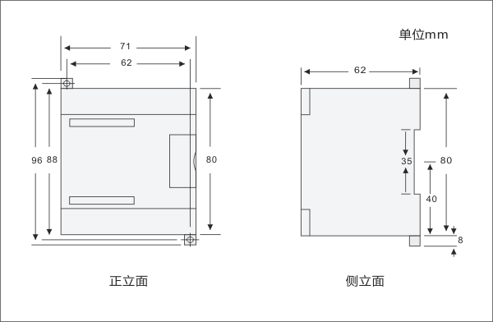  
Šema Povezivanja

