

Tehničke Karakteristike

|  |  |
| --- | --- |
| Specification | EM132, 2AQ×12BIT |
| Physical Features | |
| Dimensions(W×H×D) | 46×80×62mm |
| Power Loss(dissipation) | 2W |
| Power Consumption | |
| From +5V(from I/O bus) | 24mA |
| From L+ | 61mA |
| L+  voltage range,class 2 or DC sensor supply | 20.4～28.8V DC |
| LED indicator | 24 VDC Power Supply  Good            ON = no fault,            OFF = no 24 VDC power |
| Analog Output Features | |
| Number of analog output points | 2 |
| Isolation (field side to logic circuit) | Optical isolated: 500VAC, 1 minute |
| Signal range | |
| Voltage output         Current output | ±10V  0～20mA |
| Resolution, full-scale | |
| Voltage output         Current output | 12BIT  11BIT |
| Data word format | |
| Voltage output         Current output | -32000~+32000  0~32000 |
| Accuracy | typical: ±0.5% of full scale;    Worse: ±2% of full scale |
| Setting time | |
| Voltage output         Current output | 100μs  2ms |
| Maximum drive@24VDC power | |
| Voltage output         Current output | 5000 ohm, minimum 500 ohm, maximum |

Note

The 12 bits readings of the digital-to-analog converter (DAC) are left-justified in the output data word format.

The MSB is the sign bit: zero indicates a positive data word value. The four trailing zeros are truncated before

being loaded into the DAC registers. These bits have no effect on the output signal value.

Dimenzije

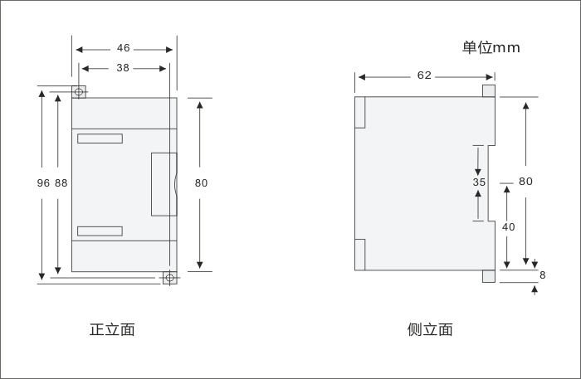

Šema Povezivanja

